**Практичне завдання “Work-case 2”**

**1. Install a type II hypervisor on your home workstation - Virtual Box, VMWare Workstation, Hyper-V (or another one of your choice). (робила студентка Андрущик Поліна)**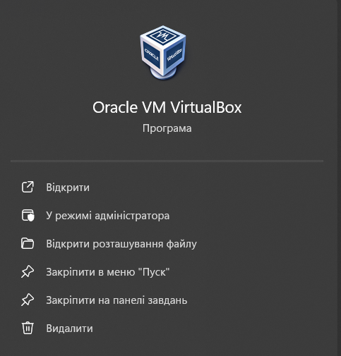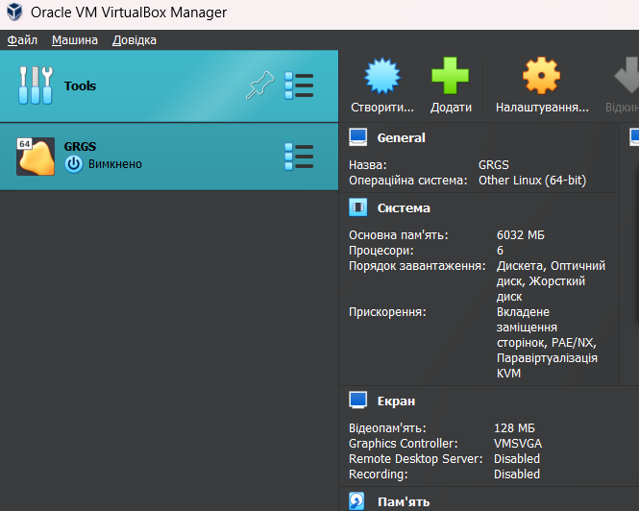  
**2. Describe a set of basic actions in the hypervisor you installed: (робила студентка Андрущик Поліна)**  
-Creation of a new virtual machine;  
-Selecting/adding equipment available for the virtual machine;  
-Network settings and connection to Wi-Fi points;  
-Ability to work with external media (flash memory).

**Creating a new virtual machine:**-Open Virtual Box.  
-Click the "Create" button.  
-Enter a name for the virtual machine and select the type of operating system you -want to install.  
-Select the amount of RAM for the virtual machine.  
-Create a virtual hard disk or select an existing one.  
-Click "Create".

**Selecting/adding hardware available to the virtual machine:**-Select a virtual machine from the list.  
-Click the "Settings" button.  
-Go to the "System" tab.  
-In the "Motherboard" section, you can change the type of motherboard, the number of processors and cores.  
-In the "Memory" section, you can change the amount of RAM.  
-In the "Media" section, you can add or remove virtual disks, as well as connect a CD/DVD drive.  
-Click "OK".

**Network settings and connection to Wi-Fi points:**-Select a virtual machine from the list.  
-Click the "Settings" button.  
-Go to the Network tab.  
-Select the adapter type (NAT, Bridged, Host-only).  
-If you selected the "NAT" adapter type, the virtual machine will access the Internet through your primary network card.  
-If you selected the "Bridged" adapter type, the virtual machine will be connected to your local network as a separate device.  
-Click "OK".  
  
**Ability to work with external media (flash memory):**-Connect the flash drive to your computer.  
-Select a virtual machine from the list.  
-Click the "Settings" button.  
-Go to the "Media" tab.  
-Click the "Add" button.  
-Select the media type "USB".  
-Select your flash drive from the list.  
-Click "OK".

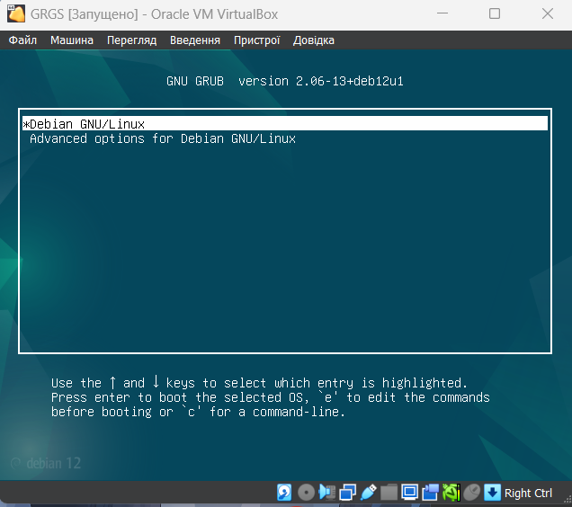3**. Install the GNU/Linux CentOS operating system (or another convenient distribution for you) in the basic configuration with graphics shell. (робила студентка Андрущик Поліна)**

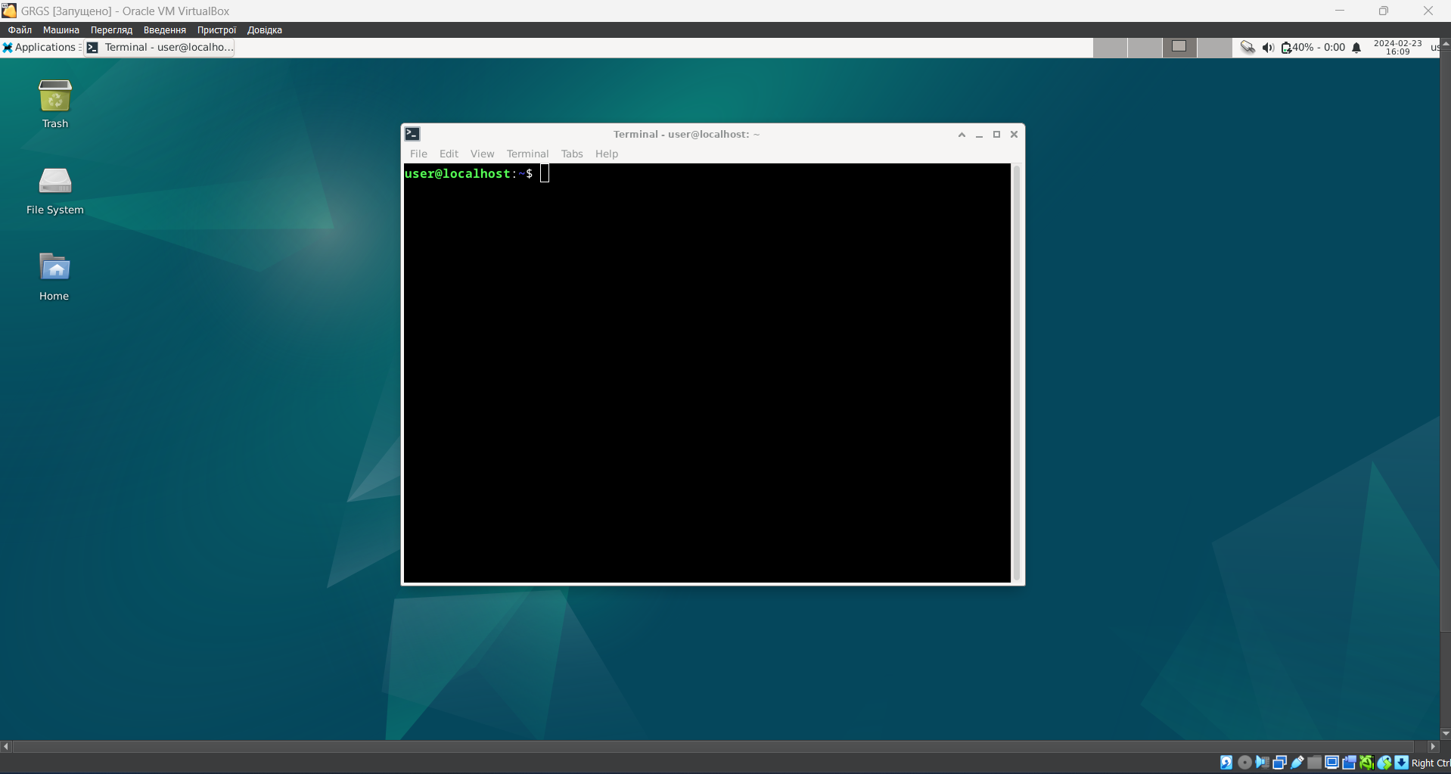

4. Create a second virtual machine and do the following for it:(робив студет Бурбан Данило)

- Install the GNU/Linux CentOS operating system in a minimal configuration with terminal input-output without a graphical interface;

**i installed ubuntu**

